Facebook and Twitter, Venturing into Social Media
Whether you take part in social media or not, you can’t avoid the fact that it has become an important part of a media literate society. It is hard to find an advertisement that doesn’t encourage you to follow them on Twitter or “Like” their page on Facebook. For this post I’ve read and engaged with school library Facebook pages as well as multiple education technology leaders on Twitter. Here I’ll share my “aha” moments as well as recommendations.
Facebook School Library Pages
John H. Wood Middle School Library
This library page included several pictures of items students had built or created in the library. From all the photos, it is apparent their library works closely with the school’s AVID program. They also posted up news of an upcoming author visit and then shared pictures from the event. There weren’t tons of posts, but they did link to the library’s monthly newsletter which included all of the above information as well as additional content.
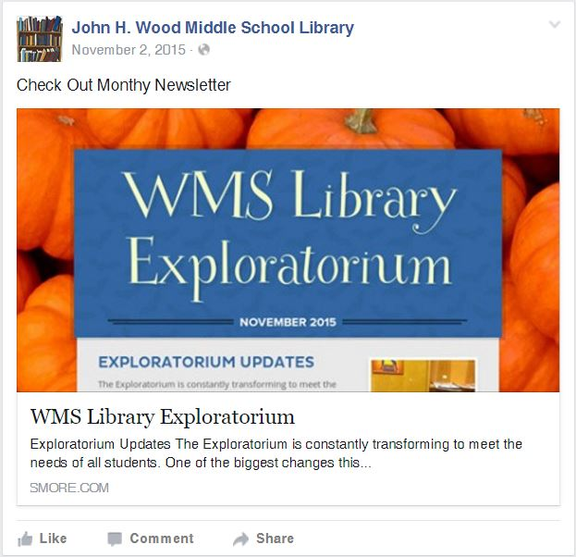
Roosevelt Theodore Senior High School Library
The Roosevelt High School library page, while starting on its own, has been merged with the rest of the school’s Facebook page, and even though I scrolled for several minutes, I couldn’t find a single post from their library. I wouldn’t have mentioned it here, but seems like an important thing to take note of—keep the pages separate if you want to stand out.
Brandeis High School Library
This is the library page of my high school’s rival. The librarian typically posts 1-2 times a month, sharing reminders for upcoming events both in and out of the library, as well as information for book fans like reminders for The 5th Wave movie. She also shares congratulations for student accomplishments and pictures of library activities like Hour of Code. There aren’t many comments on the page, but one comment I could see was from the YA author, Cynthia Leitich Smith. Likes on posts don’t seem to go over seven for any single post, but the names of the people clicking Like aren’t the same time after time. That gives the idea that more people are viewing the page than it may appear at first.
O’Connor High School Library
This is the high school I work at! There weren’t many school libraries to choose from on my list, and even fewer posting regularly, so I decided to include the Facebook page that influences me—it was on my search list, after all. The O’Connor librarian posts multiple times a month, with regular updates to upcoming activities as well as pictures from the event itself. Sometimes there are links to outside author events, but currently the focus is clearly on the upcoming LibraryPalooza. There are regular postings showing awesome free items students can get from attending, as well as information about the books and authors they’ll be able to meet. The posts themselves don’t have many likes or comments, and the librarian has mentioned before that she isn’t sure how many students view the page, but enough students let her know they enjoyed something posted up that she continues the upkeep. Students at book club meetings have requested that she include Tumblr as one of the forms of social media for the library, but because the district has it blocked, she would need to create a personal account and update it from her phone—not the ideal.
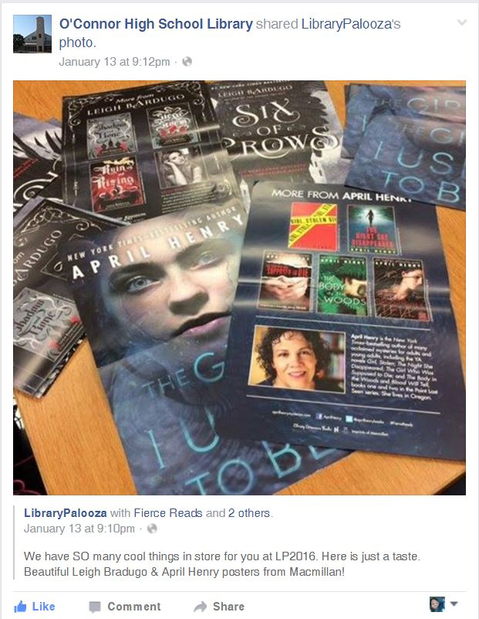

Twitter Ed Tech Leaders
Kathy Schrock @kathyschrock
Kathy Schrock definitely loves tech. She is also clearly dedicated to helping facilitate the use of technology in the classroom. I followed links through to blog posts about SAMR and going beyond it as well as Tweets about learning to use infographics in your classroom. 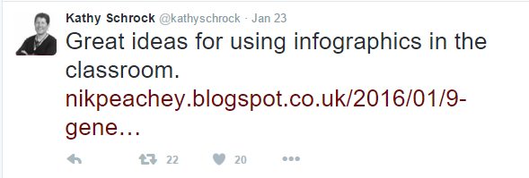
One of my favorite moments while reading her Tweets was when I realized the link I had clicked through to was written by another ed tech leader I’ve been following for a long time, Richard Byrnes @rmbyrne. It’s fun to see how people are brought together on Twitter and how interconnected our world can be.

Linda W. Braun @lbraun2000
A lot of what I saw and clicked through from Linda Braun’s Twitter feed had to do with thinking about what we are teaching students and how we are teaching students. Although her feed isn’t as blatant as some, there is quite a bit of educational activism going on in her Retweets. The infograph she shared and this link leads to really caught my attention: http://www.youthtruthsurvey.org/college-and-career-readiness/. I’ve seen the same thing when it comes to really preparing our youth for college and career, and that so much of the focus comes too late for our students to feel like they can go out and conquer the world. Braun’s feed is mainly Retweets with her own commentary or quotes, and it was interesting how she managed to make this feel quite personal. As much as she is sharing out with the world, you can also see her thought process. This was one of my favorites: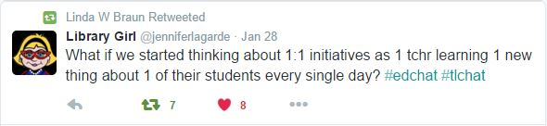
And this article about Genius Hours was really helpful because so much of it spoke to implementation rather than simply raving about how cool Genius Hours can be.
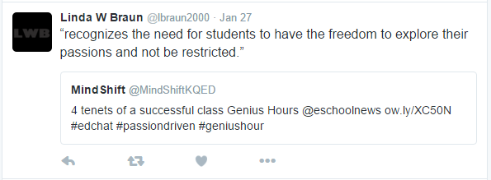

Buffy Hamilton @buffyjhamilton
Buffy Hamilton’s Twitter feed is the most personal of the ed tech people I’ve looked at so far. Through her frequent Tweets, it is clear that she is absolutely passionate about her work, and she loves sharing what she does with others.
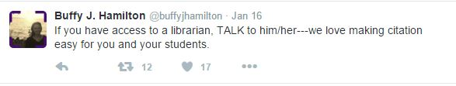
Following through on links she has Retweeted, I found this amazing gem about collaborative overload. It was such a great article that I Retweeted it myself and then Pinned it (Pinterest, yet another form of social media) so I could share it with more colleagues.
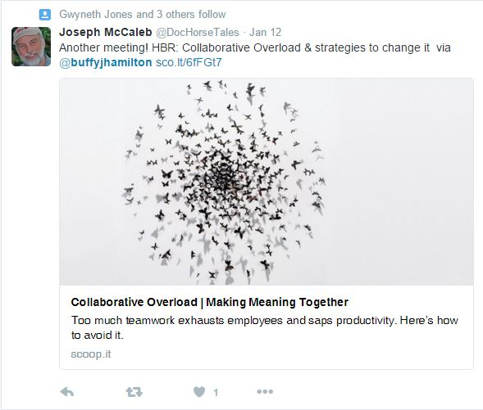
The Daring Librarian @GwynethJones
The Daring Librarian might just be the queen of the startup makerspaces, and after reading her blog post attached to the Tweet below, I found myself wanting to run out and make a Lego wall of my own and then sit down and do some coloring. She offers very practical advice on starting a makerspace in your library, “baby steppin” as she calls it, and her enthusiasm is infectious.
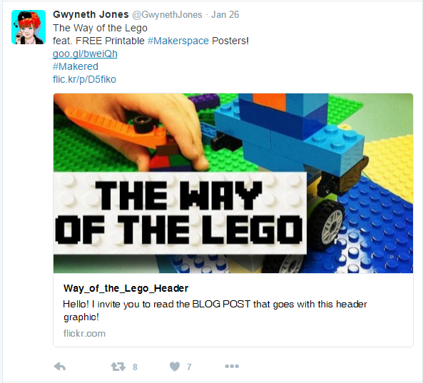
Other Tweets in her feed point to articles explaining the importance of including parents to help sustain making, and there were great pictures of adults creating together. I’ve been a bit hesitant about the whole makerspace concept, but her Tweets and blog posts make it feel very doable.
Jim Lerman @jimlerman
While some of the ed tech Twitter feeds are clearly pointed toward a specific area of expertise, Jim Lerman’s is a great blending of technology and creativity. He Retweets items from all over the technology spectrum, and not surprisingly, I saw items on his feed that had appeared in many other places, especially links to Richard Byrne’s Free Technology for Teachers. One favorite that I immediately Retweeted for myself was the list below of “16 Things Teachers Should Try in 2016.” It’s a fun list that should really encourage teaches to stretch their working with technology. 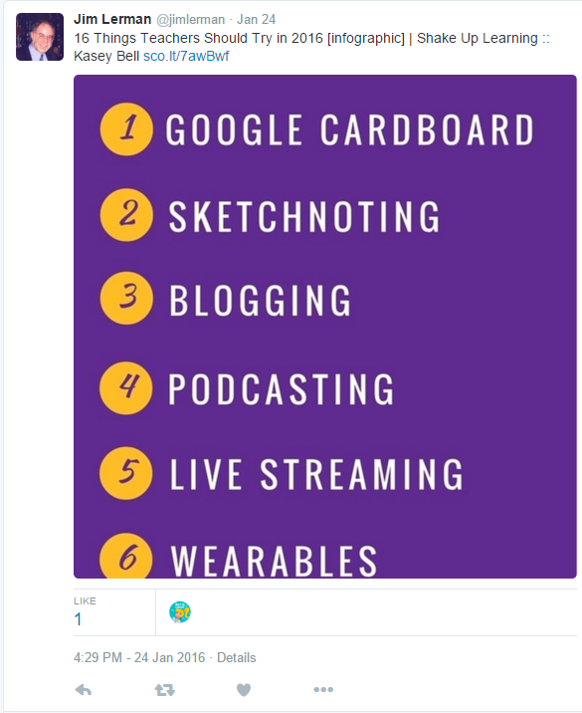
Recommendations:
Working with Facebook is fast and easy as far as promotional tools go for a library. It is designed for quick uploads from phones, so items can actually be posted as they are happening. After making a page for the elementary school library I’m interning with, I found out that you can also set standards for posts and comments, allaying some of the fears of inappropriate content slipping in where it doesn’t belong. From what I can see, though, a librarian would also have to promote the Facebook page, or all of that work is for naught. Too many great pages are going without Likes or comments because no one knows they are there. When it is done well, a Facebook page can become a fantastic and fun tool for community outreach and student engagement, but there is an amount of dedication involved to maintain a following.
Twitter is an awesome tool for learning and can also be used in a similar fashion to the Facebook pages for school libraries, but here I focused specifically on following educational technology leaders. In this instance, there is just no getting beyond the fact that Twitter is fast, easy, and anyone with a phone and Wi-Fi connection can be up and running on it with virtually no prior knowledge of how social media works. I particularly enjoyed the recursive nature of Tweets and Retweets and seeing items I found important spreading through the educational community over a period of weeks. Because so many of the leaders I followed linked to their own blogs and blogs of others in the field, I was exposed to an almost overwhelmingly large amount of interesting and current information on topics I care about.
The biggest danger of either of these forms of social media is that the vast amount of information available can lead to many hours of time spent online, and those new to social media will have to set limits for themselves. Facebook and Twitter can be addictive, but if used wisely, they can also enhance your library program and your mind.

